1)You are given an [AbstractDistance](https://drive.google.com/open?id=1ZgZDx3UIbkK9inZpG_7nZi40nEAPg4Cm) (abstract class) and a [Point](https://drive.google.com/open?id=1LiQrCV2xVFXNhTRlX3sydL6VivYd2gMX) class which present the information of a Point.

You should write cs code to create a MyDistance class which is extended from AbstractDistance class and implement the abstract method.

The method is used to calculate the distance between 2 points p1 and p2

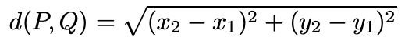

Type the following code to main method

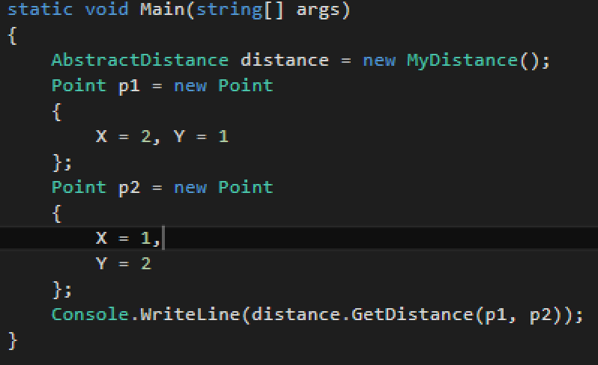

You will receive something look like the below figure:

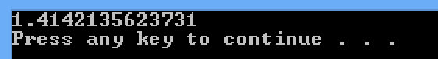

2)Given an interface [ISeason](https://drive.google.com/open?id=1bLEfm-WM9567bMorc7q-ylWSQOnQXUIp), you should write **Summer** and **Winter** classes to implement the given interface.

By running the main method

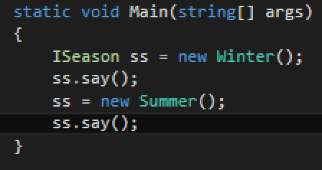

You might receive the output look something like

